Oracle installation in hq-flexdb-k-dev server

Download Oracle installation from their website Windows.X64_193000_db_home.zip

Extract the content to D:\app\db_home

Once extracted ran the setup.bat file from above directory

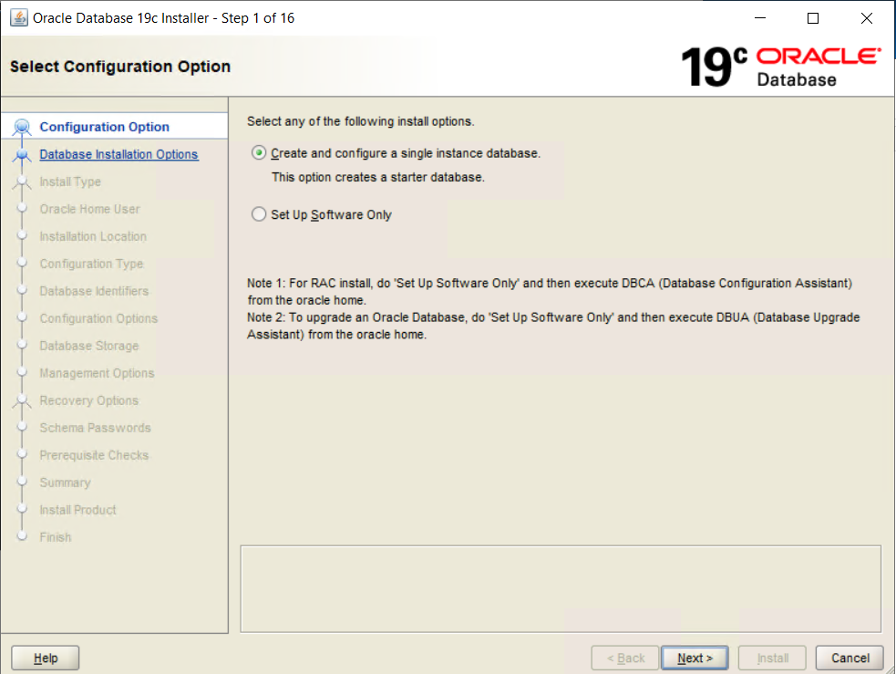

Choose – Create and Configure a single instance database and click next

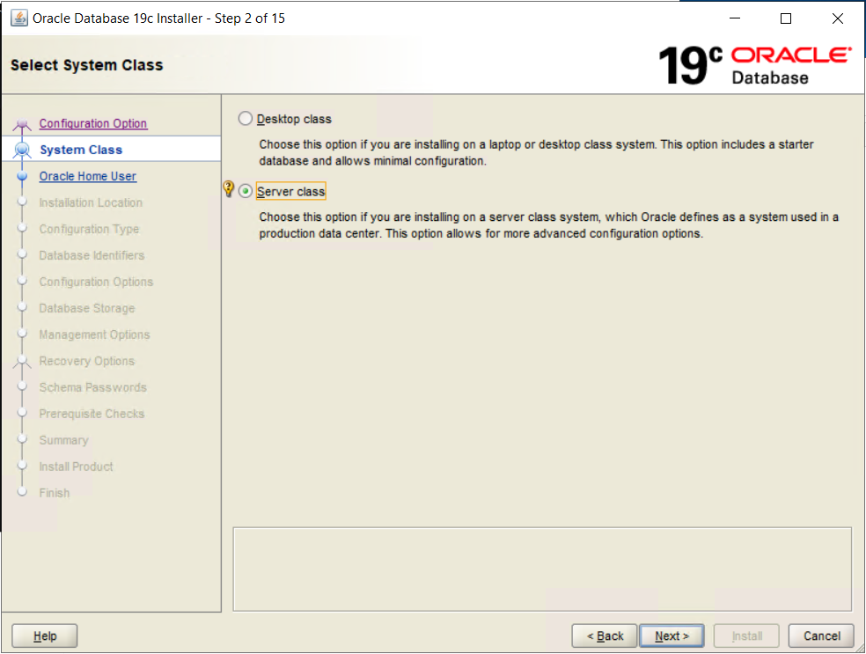

Choose Server class and click Next

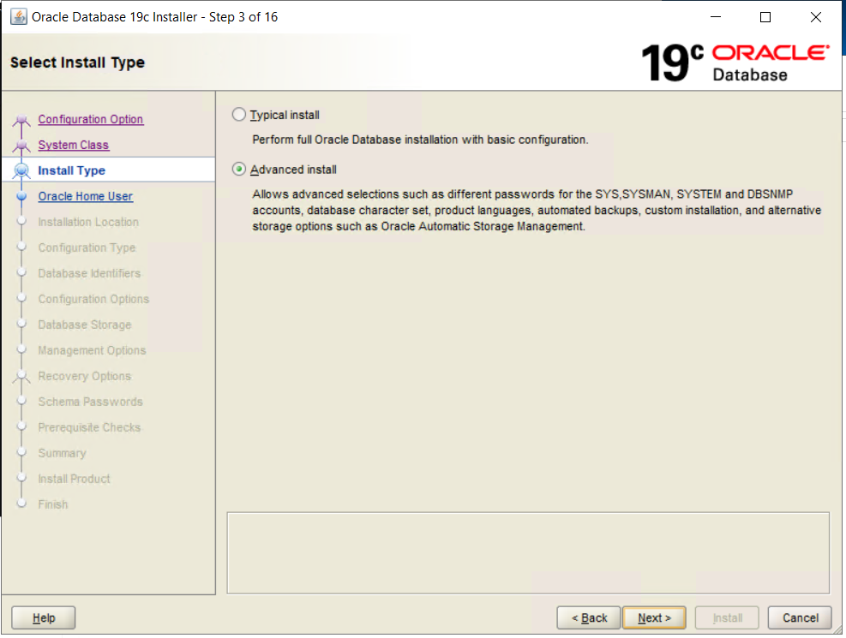

Choose Advanced install and click Next

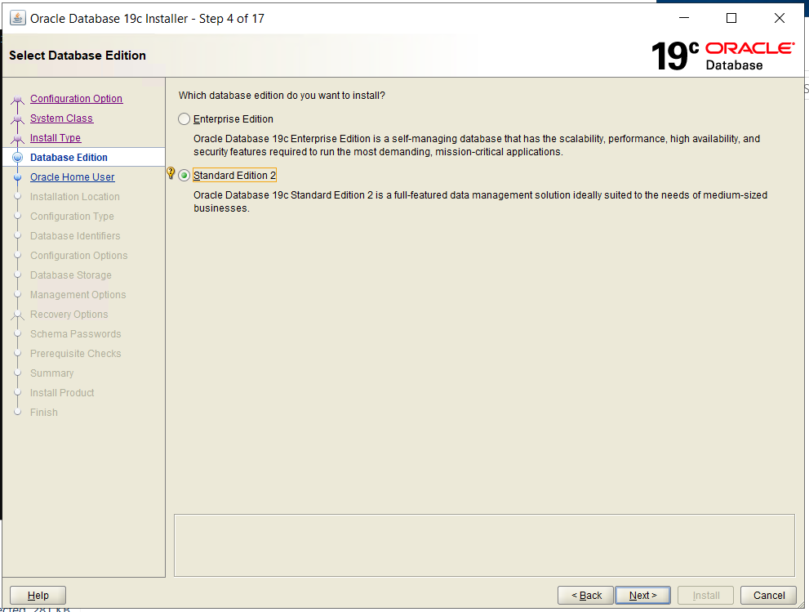

Select Standard Edition and click Next

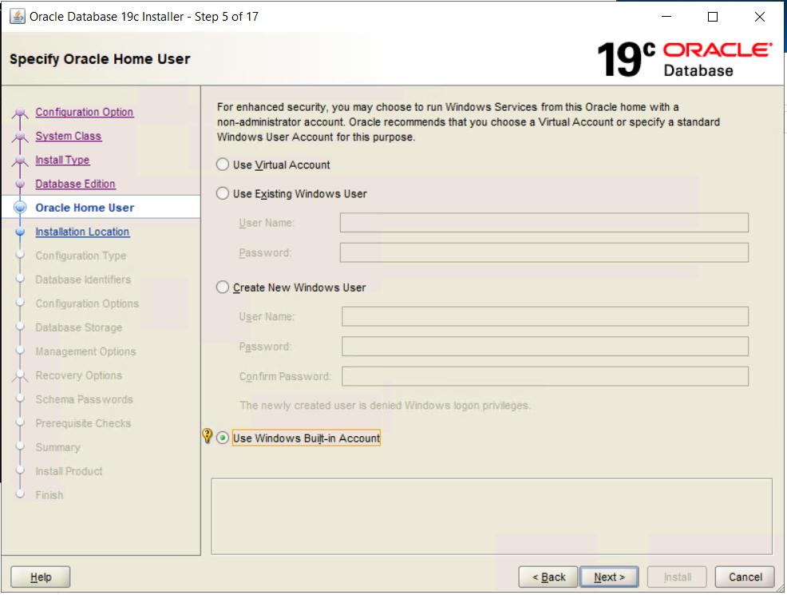

Select Use Windows Build-in Account and click Next

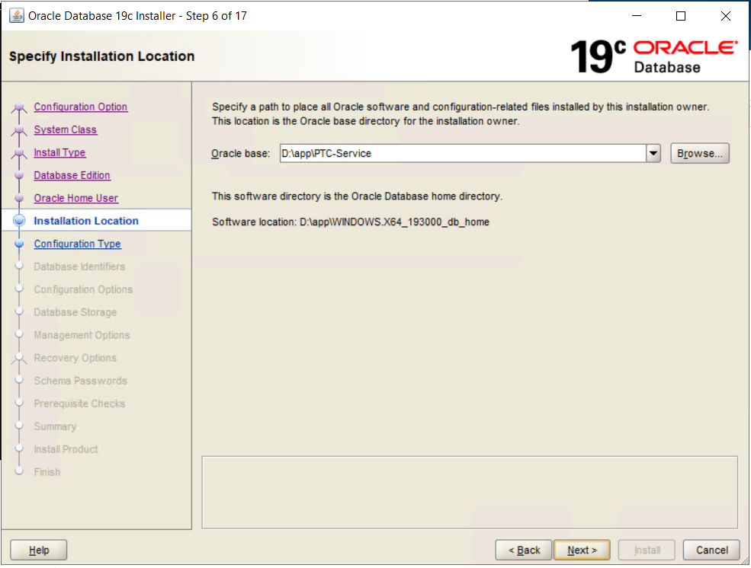

Select a directory for oracle_base (D:\app\PTC-Service) and click Next

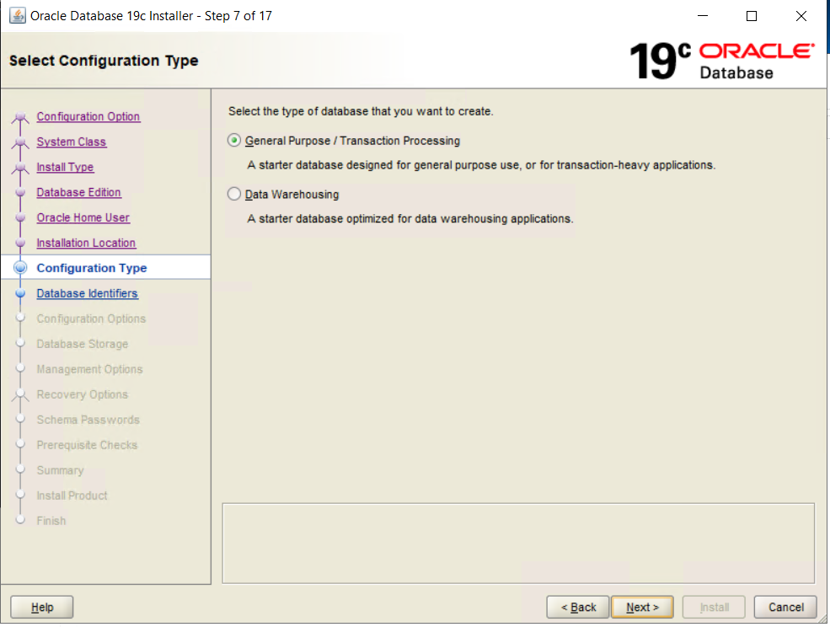

Select General purpose/Transaction processing

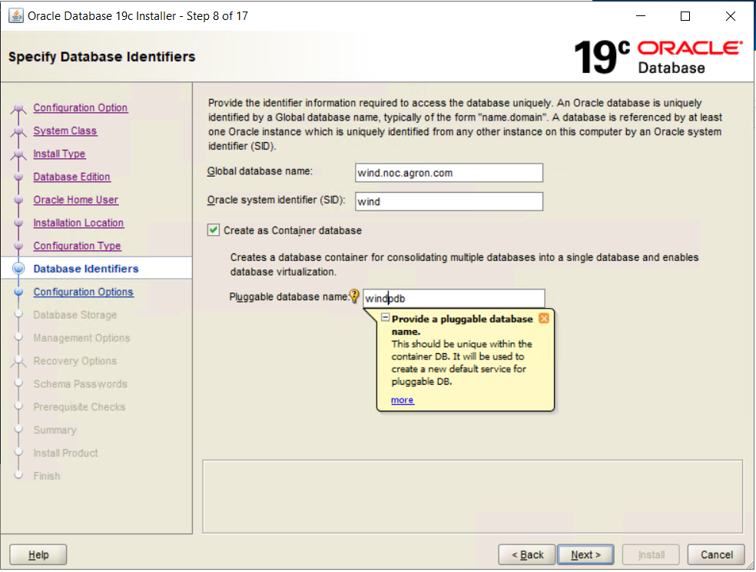

Global database name: wind.noc.agron.com(Referred during Windchill installation&upgrade)

Oracle System identifier(SID) : wind

Pluggable database name : windpdb

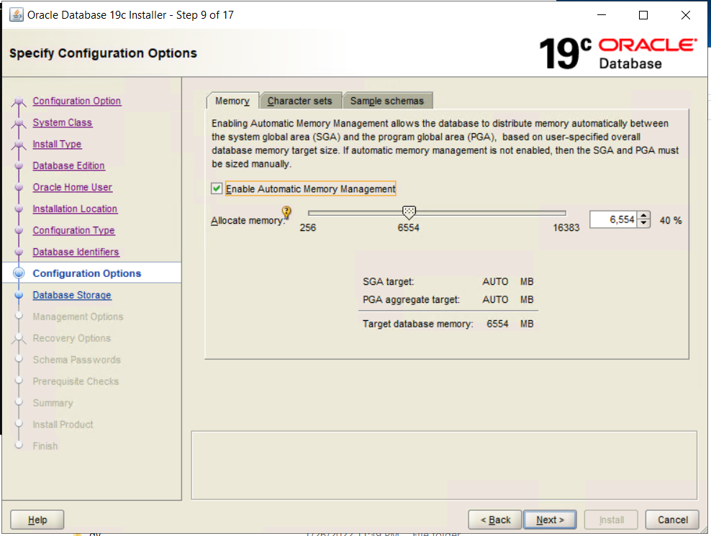

Deselect Automatic memory management

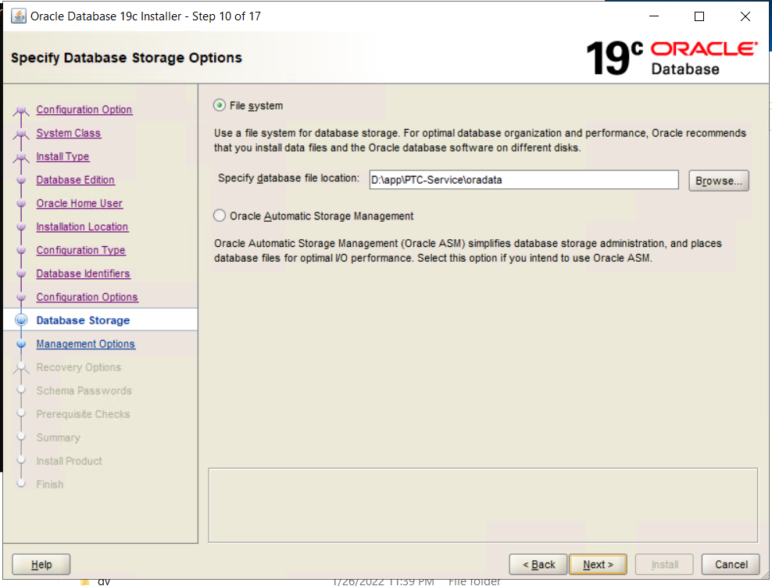

Select File system

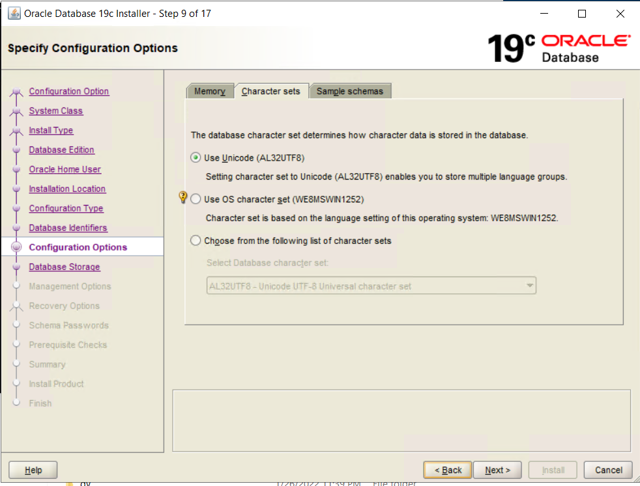

In Character sets select (Use Unicode) click Next

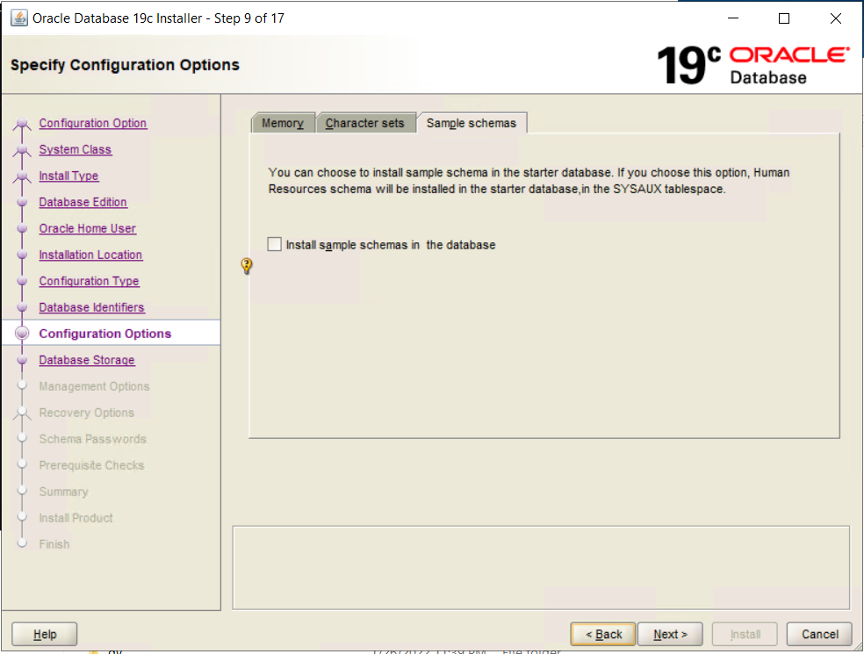

Select Schemas click Next

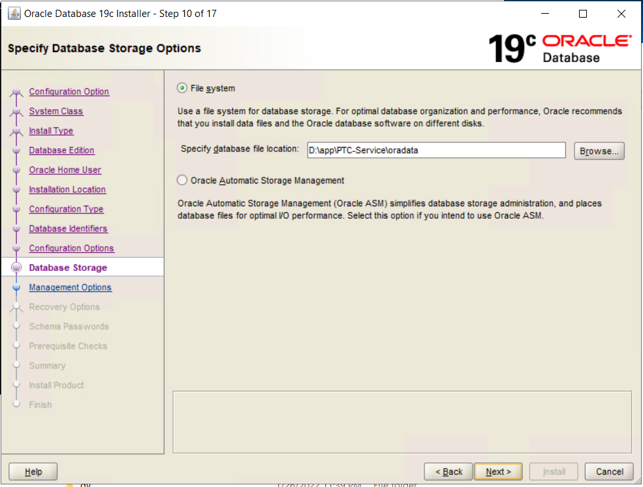

File System leave the default option and click Next

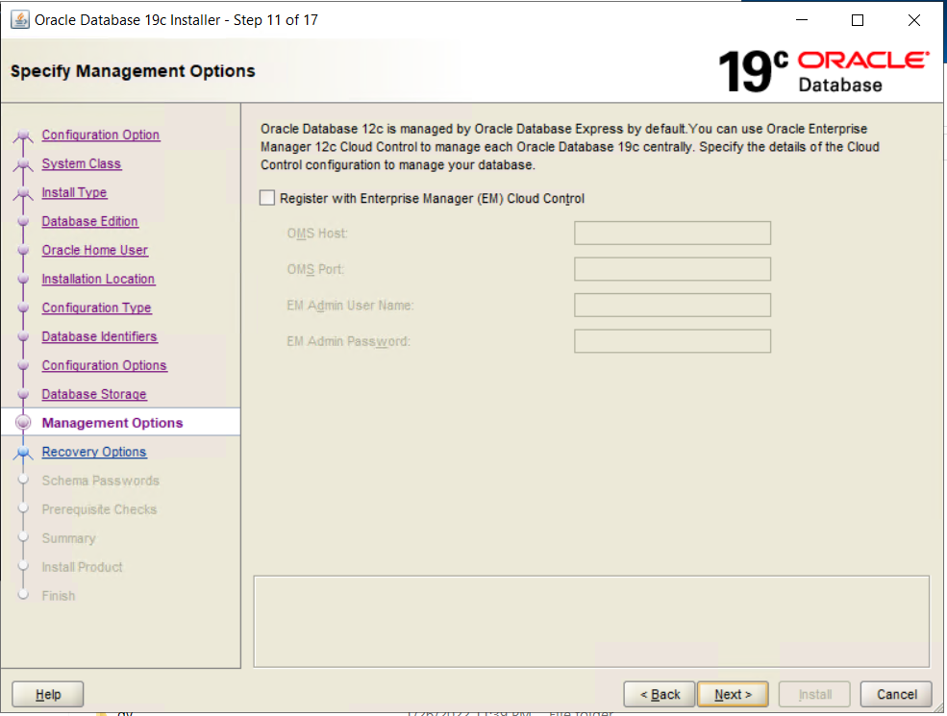

In Specify Management options click Next

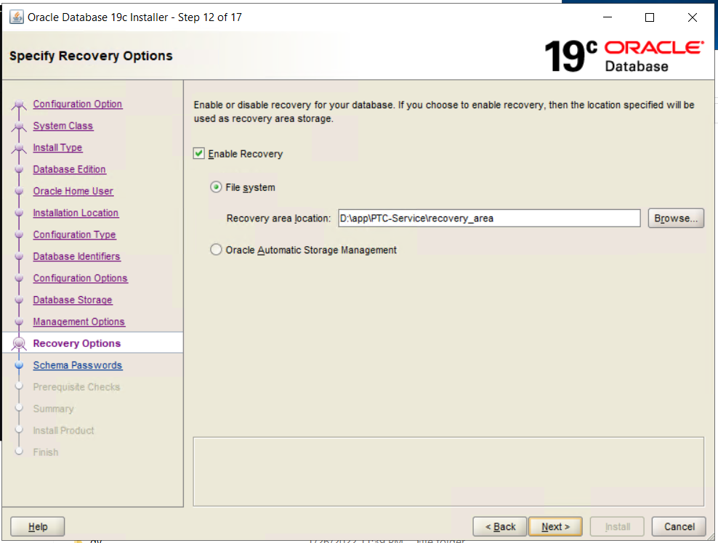

Specify Recovery option window Select Enable Recovery and file system

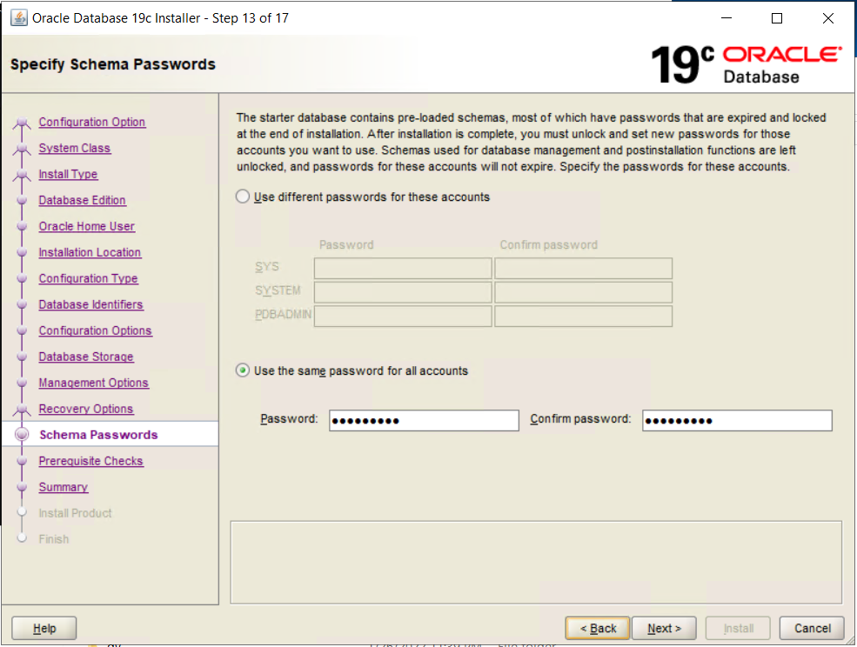

system/w1ndCh1ll

In Specify Schema passwords select “Use the same password for all accounts”

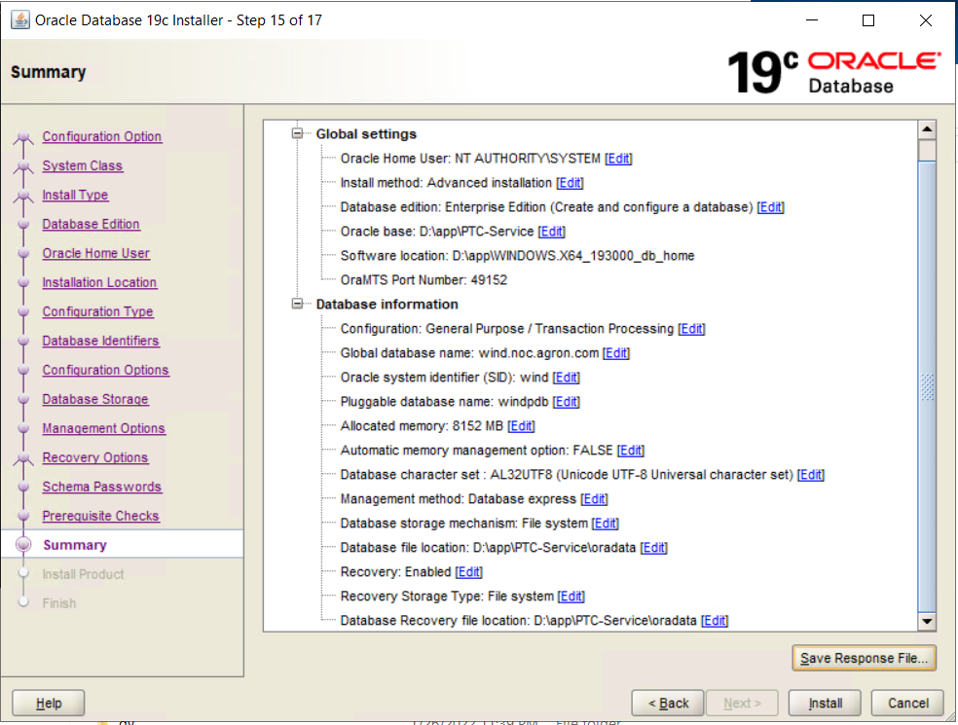

In Summary window click Install

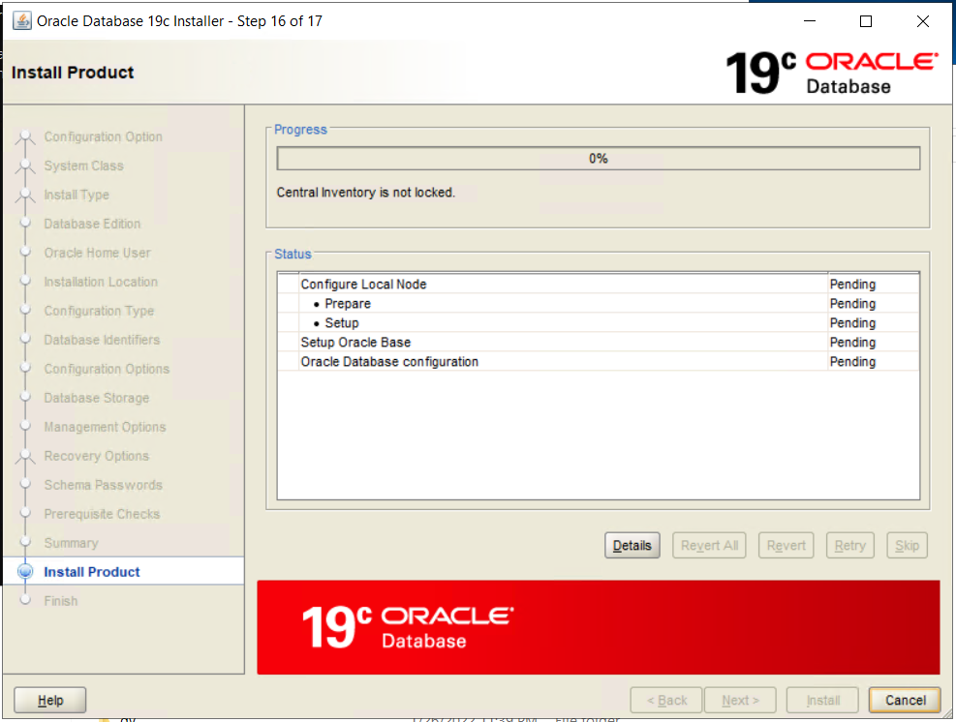

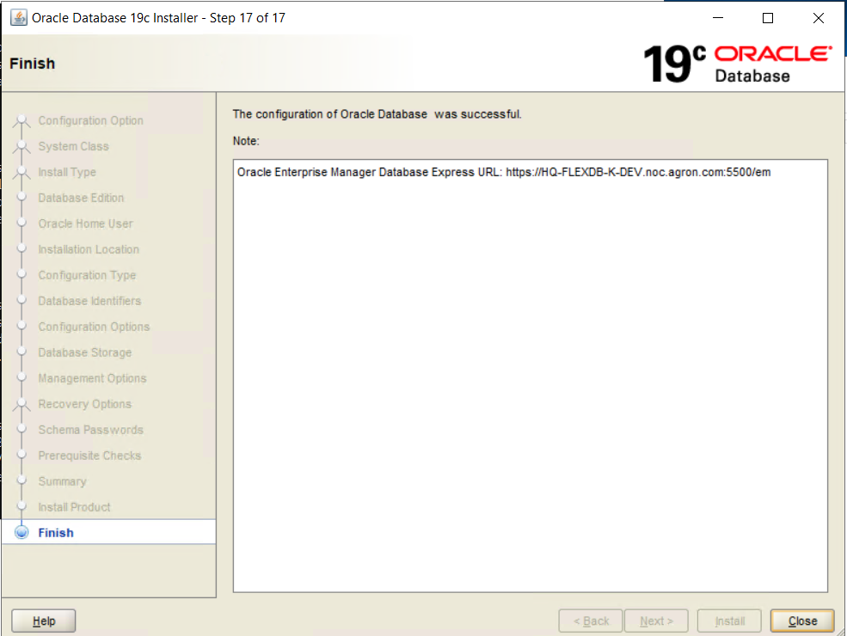

<https://HQ-FLEXDB-K-DEV.noc.agron.com:5500/em>

Once installation is completed go to command prompt

Type “sqlplus”

In user-name field type system and then the password to connect.

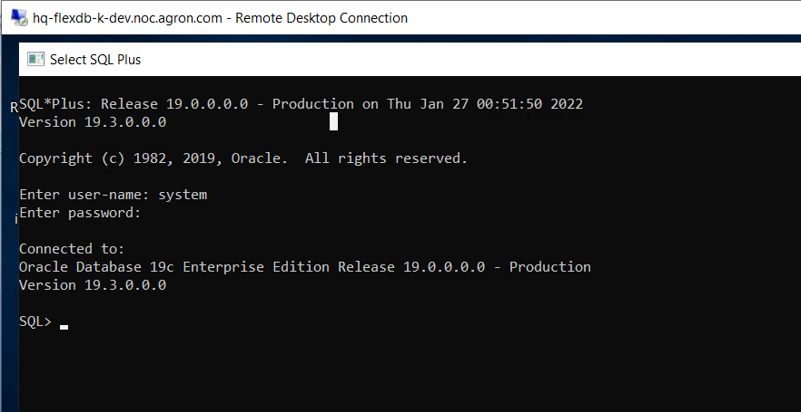

Ran the following command to create and initialize dmpdir

Create or replace directory dmpdir as ‘D:\dbWorkspace’

For creating a user use “CreateUser.sql”

Once user is created change the password using

Alter user C##newqa11 identified by newqa11;

Ran the following commands to create Database TableSpaces which are mandatory for Windchill

CREATE TABLESPACE "BLOBS" LOGGING DATAFILE 'D:\APP\PTC-SERVICE\ORADATA\WIND\BLOBS01.dbf' SIZE 1000M AUTOEXTEND ON NEXT 1M MAXSIZE UNLIMITED EXTENT MANAGEMENT LOCAL UNIFORM SIZE 128K SEGMENT SPACE MANAGEMENT AUTO;

CREATE TABLESPACE "INDX" LOGGING DATAFILE 'D:\APP\PTC-SERVICE\ORADATA\WIND\INDX01.dbf' SIZE 1000M AUTOEXTEND ON NEXT 1M MAXSIZE UNLIMITED EXTENT MANAGEMENT LOCAL UNIFORM SIZE 128K SEGMENT SPACE MANAGEMENT AUTO;

CREATE TABLESPACE "WCAUDIT" LOGGING DATAFILE 'D:\APP\PTC-SERVICE\ORADATA\WIND\WCAUDIT01.dbf' SIZE 1000M AUTOEXTEND ON NEXT 1M MAXSIZE UNLIMITED EXTENT MANAGEMENT LOCAL UNIFORM SIZE 128K SEGMENT SPACE MANAGEMENT AUTO;

SELECT NAME, VALUE FROM V$PARAMETER where lower(name) = 'db_create_file_dest';

select file_name from dba_data_files where tablespace_name = 'USERS';

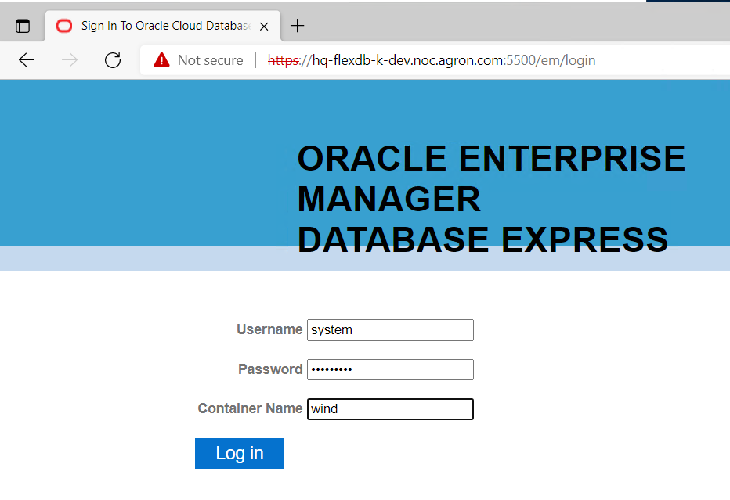

But this is not working

Some important commands

Below are the import command and export command to Oracle 12c DB

impdb system/w1ndCh11@wind DIRECTORY=dmpdir exclude=statistics dumpfile=C__WCPROD_2022-18-02_19-30-01_EXP.DMP logfile= C__WCPROD_2022-18-02_19-30-01_EXP.log schemas=c##wt121

In some cases indexs creation will be failing need to create them post import

To Export

expdp system/w1ndCh1ll@wind SCHEMAS=c##wt121 DIRECTORY=dmpdir DUMPFILE=c__wt121_DMP_230222.dmp logfile C__wt121_DMP_230222.log

To gather statistics(Post import as we have disabled it in our import command)

execute dbms_stats.gather_schema_stats(ownname=>’c##wt121’, cascade=>true)

prior to Upgrade set the below parameters

alter system set sga_max_size=16000m scope=spfile;

alter system set sga_target=16000m scope=spfile;